## **PROBLEM SOLVING WITH PROGRAMMING**

## **GUIDE:-DR.PRAVEEN.**

B.TECH 1ST year 2nd SEMESTER

PROJECT TITLE:-TOURISIM MANANGEMENT SYSTEM

TOURISIM MANANGEMENT SYSTEM

**TEAM-01 (CSE-H1)**



**TEAM MEMBERS:-**

L.SHRIHAN REEDY(2103A54025)

A.NAVYA SREE(2103A53008)

E.SIDDHARTHA(2103A54016)

B.TRISHUL(2103A54002)



# INDEX

# S.no TITLE page NO

# 1. Abstract 3

# 2. Introduction 4

# 3. Modules description 4

# 4. Implementation 5-23

# 5. Test results 23-30

# 6. Conclusions 30

# 1. abstract

To develop a menu driven program using C language , we select an online train ticket booking project from multiple options .We write code in visual studio for easy coding and we use the details of flights to be realistic and easy to be understood by everyone who uses it.

Tourism Management System is based on a concept of maintaining tour packages for the tourists. Before stepping into the main system a user has to pass through login system to get access, then only he/she can use the features of the system which includes booking package, previewing ticket, canceling a ticket, viewing tourism brochure. It also contains a sign-up feature.

Talking about the features of Tourism management system, a user needs a certain id to get access. For this, the user can simply sign up by providing username and password. After logging in as a user, there are several options to perform. The user can check for holiday packages and book. In order to book a package, the user has to select within given package details and enter the number of people. After the booking is done, he/she can check for the ticket details which displays the total price and ticket of the package. In total there are 10-holiday packages. Whenever the user wants to cancel the tickets, he/she can easily cancel it and get the refund. By using this application we can book our tour easily anywhere and this application can let you book a perfect planed trip according to your specifications like you can choose where ever you want . This project shows the login User, book Ticket, print Ticket, Cancel Ticket, Change Password ,Logout user, Check Tickets.

2.Introduction

This project web-based shopping system is more useful for reserving train tickets. This type of online booking is more convenient to customer plan a trip and go in a confortable way. We are used technology and developed different method c language in it.

3.Modules Description

Software: Dev-C++ is a free full-featured Integrated development environment distributed under the GNU General Public License for programming in C and C++. It is written in Delphi. It is bundled with, and uses, the MinGW or TDM-GCC 64bit port of the GCC as its compiler.

# In this application all variables and structure are declared globally so that these variables and structure members can be accessed throughout the program at any function call.We can choose any function bu using function calls which are declared in switch-case.In order to repeat the loop control statement (dowhile) is used with condition.The memory allocation will be done in this program dynamically.The application ask the person who runs the programs how many companies data he/she wants to store. In this application four modules are used.

# 1.Read/Input

# In this module the application asks the person who runs the

# program to enter the user id and password the Passengers who had already register To give user details for loops are used.

# 2.Print In this module all the stored details of the trip and passengers will be displayed on to the screen.In this module printf function and for loops are used.

3.Searching

In this module searching of data is done according to the chosen wise.

In this module there is a sub menu which asks to select the searching wise by using switch case.The searching sub menu will be like press 1 to search add user wise press 2 to search login user wise press 3 to search broucher wise press 4 to exit. In this module we used another control statement(do while)so that the application asks whether to continue searching or stops the searching.

# 4.Implementation Of a Compilation Units as mandated by the standard and to build a standard conforming c implantation consists of a compiler and executable file.

**CODE:-**

#include<stdio.h>

#include<stdlib.h>

#include<string.h>

enum state{menu,loggedin};

enum state currentstate=menu;

typedef struct user

{

char username[100];

char password[100];

char place[100];

float price;

int numtick;

struct user *next;

}user;

void ShowBrochure();

user* InitializeList(user*);

user* AddUser(user*);

void LoginUser(user*);

void BookTicket(user*);

void PrintTicket(user*);

void CancelTicket(user*);

void ChangePassword(user*);

void LogoutUser();

void CheckTicket(user*);

void DisplayAll(user*);

void WriteToFile(user*);

void ExitProgram();

char currentuser[100];

int main()

{

printf("\t\t\t==== || TOURISM MANAGEMENT SYSTEM || ====\n");

user *h=NULL;

int ch1,ch2;

h=InitializeList(h);

while (1)

{

if(currentstate==menu)

{

printf("\n\t\t\t\tAdd User - 1\n\t\t\t\tLogin User - 2\n\t\t\t\tBrochure - 3\n\t\t\t\tExit - 4\n\n\t\t\t\tEnter:");

scanf("%d",&ch1);

switch(ch1)

{

case 1:

h=AddUser(h);

break;

case 2:

LoginUser(h);

break;

case 3:

ShowBrochure();

break;

case 4:

ExitProgram();

exit(0);

break;

default:

printf("Not a valid input at this stage\n");

}

}

else if(currentstate==loggedin)

{

system("CLS");

printf("\n\t\t\t\t=========================");

printf("\n\t\t\t\tTOURISM MANAGEMENT SYSTEM");

printf("\n\t\t\t\t=========================\n");

printf("\n\t\t\t\tBook Package - 1\n\t\t\t\tCheck Ticket - 2\n\t\t\t\tPrint Ticket - 3\n\t\t\t\tCancel Ticket - 4\n\t\t\t\tChange Password - 5"

"\n\t\t\t\tLogout User - 6\n\t\t\t\tBrochure - 7\n\t\t\t\tExit - 8\n");

scanf("%d",&ch2);

switch(ch2)

{

case 1:

BookTicket(h);

system("PAUSE");

system("CLS");

break;

case 2:

CheckTicket(h);

system("PAUSE");

system("CLS");

break;

case 3:

PrintTicket(h);

system("PAUSE");

system("CLS");

break;

case 4:

CancelTicket(h);

system("PAUSE");

system("CLS");

break;

case 5:

ChangePassword(h);

system("PAUSE");

system("CLS");

break;

case 6:

LogoutUser(h);

system("PAUSE");

system("CLS");

break;

case 7:

ShowBrochure();

system("PAUSE");

system("CLS");

break;

case 8:

ExitProgram();

exit(0);

break;

default:

printf("Not a valid input at this stage\n");

}

}

}

return 0;

}

user* InitializeList(user *h)

{

user* t,*ptr,temp;

FILE *fp;

int cc=0,x;

float ff;

fp=fopen("users.txt","r");

if(fp==NULL)

return NULL;

if(fgetc(fp)==EOF)

return NULL;

rewind(fp);

while(fscanf(fp,"%s %s %s %f %d",temp.username,temp.password,temp.place,&temp.price,&temp.numtick)!=EOF)

{

ptr=(user*)malloc(sizeof(user));

strcpy(ptr->username,temp.username);

strcpy(ptr->password,temp.password);

strcpy(ptr->place,temp.place);

ptr->price=temp.price;

ptr->numtick=temp.numtick;

ptr->next=NULL;

if(h==NULL)

h=t=ptr;

else

{

h->next=ptr;

h=ptr;

}

}

fclose(fp);

return t;

}

void WriteToFile(user *h)

{

FILE *fp;

fp=fopen("users.txt","w");

while(h!=NULL)

{

fprintf(fp,"%s %s %s %f %d\n",h->username,h->password,h->place,h->price,h->numtick);

h=h->next;

}

fclose(fp);

}

void ShowBrochure()

{

system("CLS");

printf("\tPRICE LIST\n=============================\n1. LL - Antelope Canyon Tours - Rs 40000\n2. JK - Grand Canyon Local Tours - Rs 60000\n3. SK - San Francisco Local Tours - Rs 25000\n4. SHM - Miami Vacation - Rs 38000\n"

"5. AND - Hawaii - Rs 120000\n6. BHB - Atlanta Vacation - Rs 10000\n7. AG - San Francisco - Rs 30000\n8. ND - Alaska Vacation - Rs 32000\n9. RJ - Orlando Vacation - Rs 45000\n10. SI - South US Tour - Rs 250000\n");

}

void CheckTicket(user *h)

{

while(h!=NULL)

{

if(!strcmp(h->username,currentuser))

break;

h=h->next;

}

if(!strcmp(h->place,"\0") || h->price==0.0 || h->numtick==0)

{

printf("You do not have a ticket booked yet\n");

return;

}

float total=0.0;

total=(h->price)*(h->numtick);

printf("You have booked %d tickets for a sum total of Rs %f for tour code %s\n",h->numtick,total,h->place);

}

user* AddUser(user* h)

{

user *t;

t=h;

user *nw;

nw=(user*)malloc(sizeof(user));

fflush(stdin);

printf("Enter username or email\n");

scanf("%s",nw->username);

while(h!=NULL)

{

if(!strcmp(h->username,nw->username))

{

printf("That email already exists\n");

return t;

}

h=h->next;

}

h=t;

fflush(stdin);

printf("Enter password\n");

scanf(" %[^\n]s",&nw->password);

nw->next=NULL;

strcpy(nw->place,"N/A");

nw->price=0.0;

nw->numtick=0;

if(h==NULL)

{

h=t=nw;

}

else

{

while(h->next!=NULL)

{

h=h->next;

}

h->next=nw;

}

WriteToFile(t);

return t;

}

void LoginUser(user* h)

{

char username[100];

char password[100];

fflush(stdin);

printf("\n\n");

printf("\t\tEnter Email/Username:\n\t\t");

scanf("%s",username);

fflush(stdin);

printf("\n\t\tEnter Password:\n\t\t");

scanf(" %[^\n]s",password);

while(h!=NULL)

{

if((!strcmp(h->username,username)) && (!strcmp(h->password,password)))

{

currentstate=loggedin;

strcpy(currentuser,username);

printf("\n\t\tLogin successful!\n");

system("PAUSE");

return;

}

else if((!strcmp(h->username,username)) && (strcmp(h->password,password)))

{

printf("Password mismatch\n");

return;

}

h=h->next;

}

printf("Sorry, no such user record was found\n");

}

void BookTicket(user *h)

{

user *t=h;

char place[100];

while(h!=NULL)

{

if(!strcmp(h->username,currentuser))

break;

h=h->next;

}

if(h==NULL)

return;

if(h->price!=0.0)

{

printf("You must cancel your previous ticket before buying a new one\n");

return;

}

ShowBrochure();

float pricelist[]={40000.0,60000.0,25000.0,38000.0,120000.0,10000.0,30000.0,32000.0,45000.0,250000.0};

fflush(stdin);

printf("\nEnter place code (eg: LL, JK)\n");

scanf(" %[^\n]s",place);

char choice;

fflush(stdin);

printf("\nWould You Like to Confirm Booking?\n[1] - Yes\n[2] - No\n");

scanf("%c",&choice);

float price;

if(choice!='1')

return;

if(strcmp(place,"LL")==0)

price=pricelist[0];

else if(strcmp(place,"JK")==0)

price=pricelist[1];

else if(strcmp(place,"SK")==0)

price=pricelist[2];

else if(strcmp(place,"SHM")==0)

price=pricelist[3];

else if(strcmp(place,"AND")==0)

price=pricelist[4];

else if(strcmp(place,"BHB")==0)

price=pricelist[5];

else if(strcmp(place,"AG")==0)

price=pricelist[6];

else if(strcmp(place,"ND")==0)

price=pricelist[7];

else if(strcmp(place,"RJ")==0)

price=pricelist[8];

else if(strcmp(place,"SI")==0)

price=pricelist[9];

else

{

printf("That tour code doesn't exist\n");

return;

}

printf("Enter the number of tickets you want to book?\n");

scanf("%d",&h->numtick);

if(h->numtick==0)

return;

strcpy(h->place,place);

h->price=price;

WriteToFile(t);

printf("Bookings Done!!\n");

system("PAUSE");

}

void PrintTicket(user *h)

{

while(h!=NULL)

{

if(!strcmp(h->username,currentuser))

break;

h=h->next;

}

if(!strcmp(h->place,"\0") || h->price==0.0 || h->numtick==0)

{

printf("You do not have a ticket booked yet\n");

return;

}

float total=0.0;

total=(h->price)*(h->numtick);

FILE *fp;

char filename[50];

strcpy(filename,h->username);

strcat(filename,"_ticket.txt");

fp=fopen(filename,"w");

if(fp==NULL)

{

printf("Problem opening the file\n");

return;

}

if(fgetc(fp)==EOF)

{

fprintf(fp,"TOURISM TICKET\n===============\n\n");

}

fprintf(fp,"Email ID: %s\nTour Code: %s\nTicket Cost: Rs %f\nNumber of tickets: %d\nTotal Cost: Rs %f\n",h->username,h->place,h->price,h->numtick,total);

fclose(fp);

}

//TMS1353f

void CancelTicket(user *h)

{

user *t=h;

while(h!=NULL)

{

if(!strcmp(h->username,currentuser))

break;

h=h->next;

}

int flag=-1;

if(h==NULL)

printf("No such user\n");

if(strcmp(h->place,"LL")==0)

flag++;

else if(strcmp(h->place,"JK")==0)

flag++;

else if(strcmp(h->place,"SK")==0)

flag++;

else if(strcmp(h->place,"SHM")==0)

flag++;

else if(strcmp(h->place,"AND")==0)

flag++;

else if(strcmp(h->place,"BHB")==0)

flag++;

else if(strcmp(h->place,"AG")==0)

flag++;

else if(strcmp(h->place,"ND")==0)

flag++;

else if(strcmp(h->place,"RJ")==0)

flag++;

else if(strcmp(h->place,"SI")==0)

flag++;

else

{

printf("You haven't booked a tour yet\n");

return;

}

if(flag==0)

{

printf("Your ticket has been successfully cancelled\nA refund of Rs %f for Tour Code %s for %d tickets will soon be made to your original source of purchase\n",h->price,h->place,h->numtick);

strcpy(h->place,"N/A");

h->price=0.0;

h->numtick=0;

WriteToFile(t);

}

}

void ChangePassword(user *h)

{

user *t=h;

char passcurr[100];

fflush(stdin);

printf("Enter your current password to continue:\n");

scanf(" %[^\n]s",passcurr);

while(h!=NULL)

{

if(!strcmp(h->username,currentuser))

break;

h=h->next;

}

if(h==NULL)

return;

if(!strcmp(passcurr,h->password))

{

printf("Enter new password:\n");

scanf(" %[^\n]s",h->password);

}

WriteToFile(t);

}

void LogoutUser()

{

if(currentstate==menu || strcmp(currentuser,"\0")==0)

{

printf("You must be logged in to logout\n");

return;

}

strcpy(currentuser,"\0");

currentstate=menu;

printf("You have been successfully logged out\n");

}

void ExitProgram()

{

printf("Exiting...\nDeveloped By Gropu 3\nPress \"Enter/Return\" to exit");

char exitprog;

fflush(stdin);

scanf("%c",&exitprog);

}

Test results:-

Output:-

Login page

1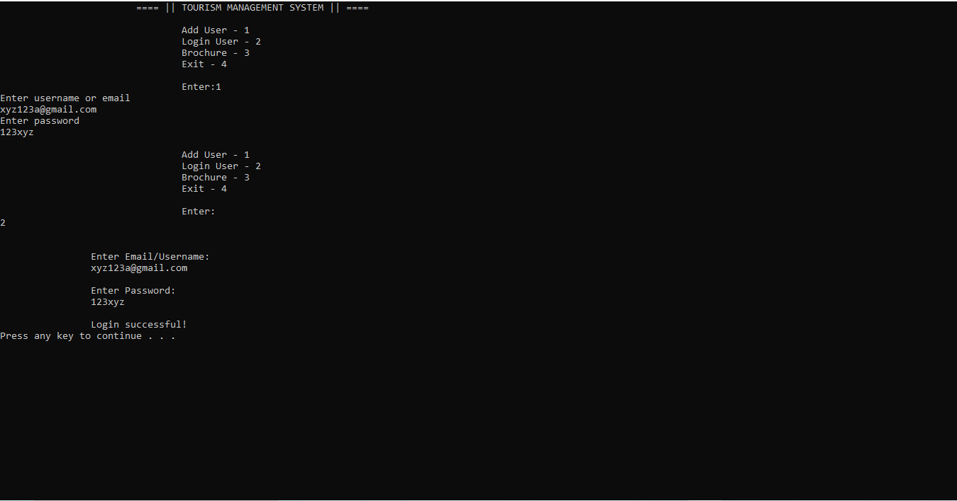

2

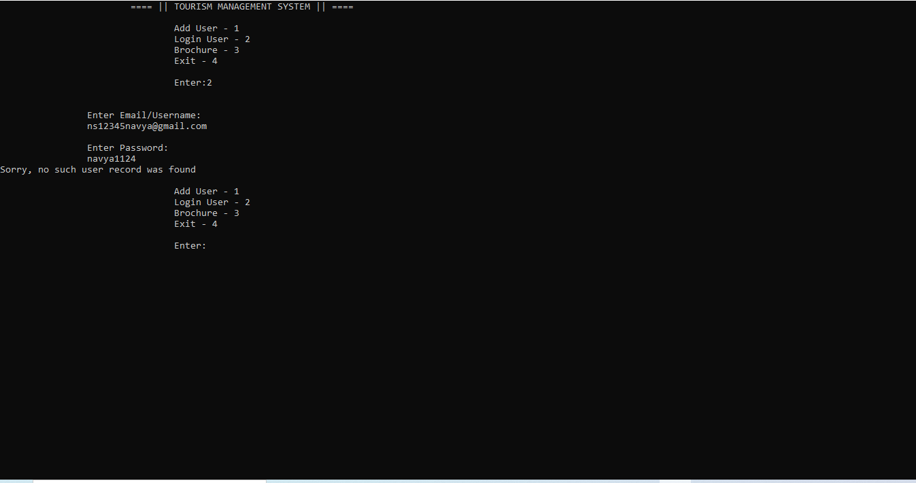

MENU

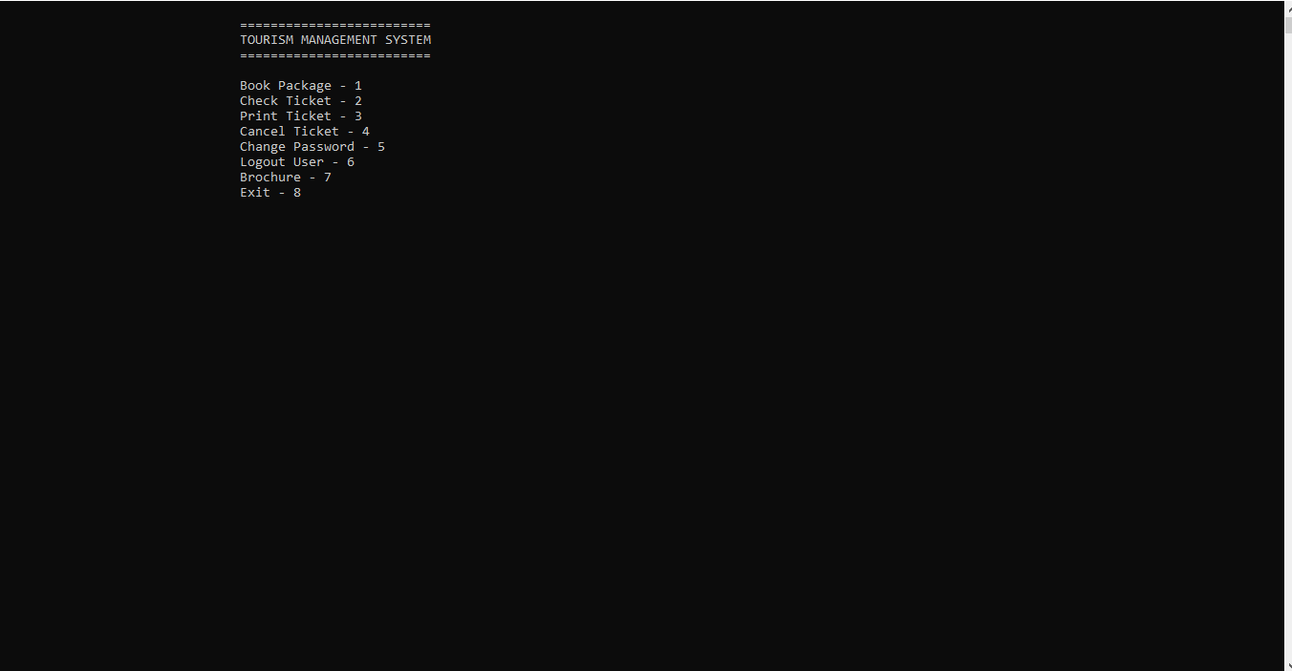

PRICE LIST:

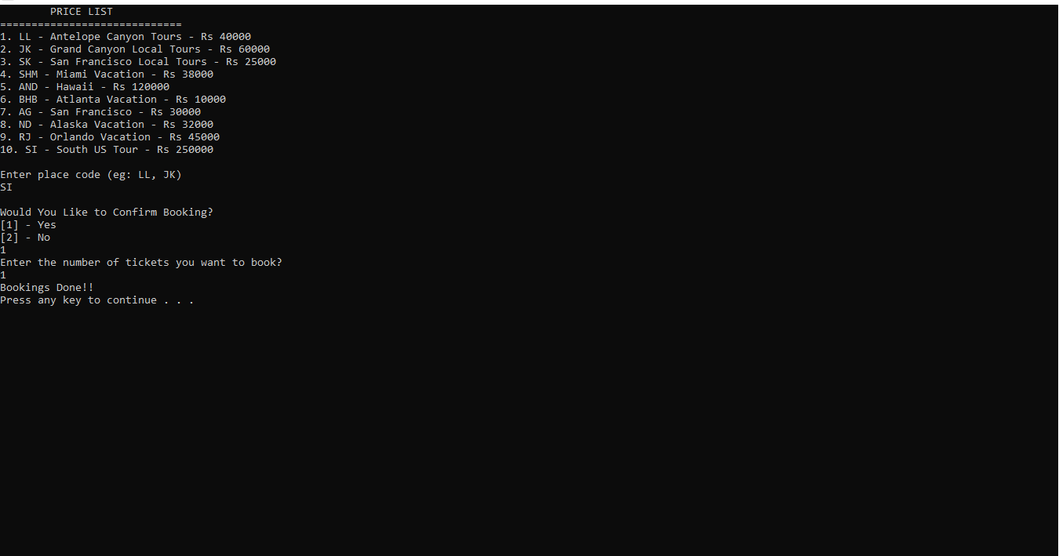

Booking tickets:

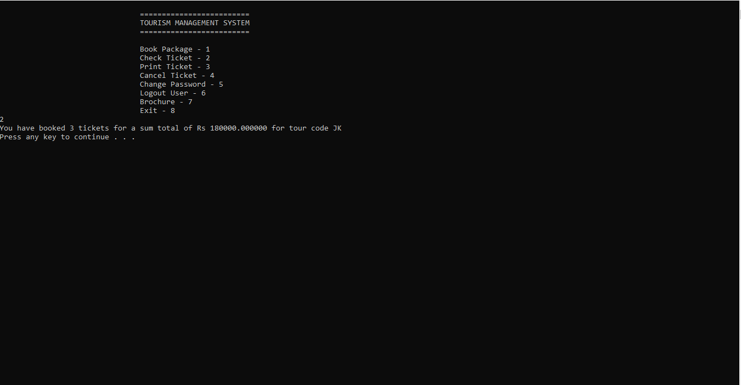

Cancelation:

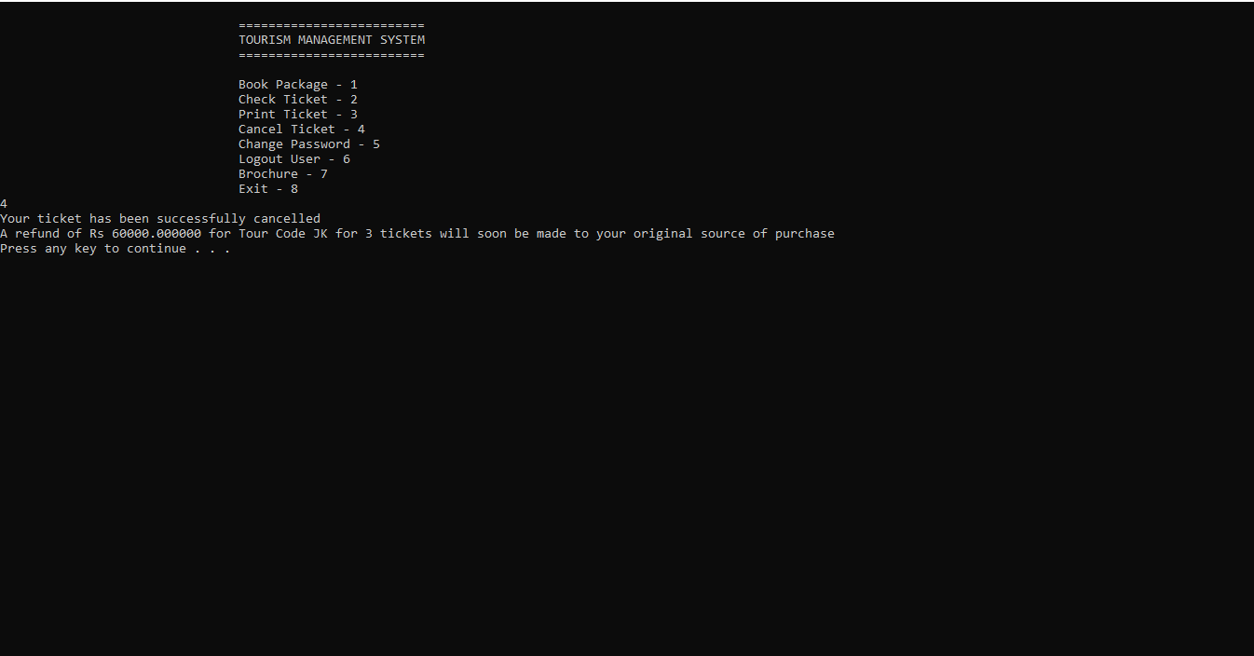

Brochure:

1.

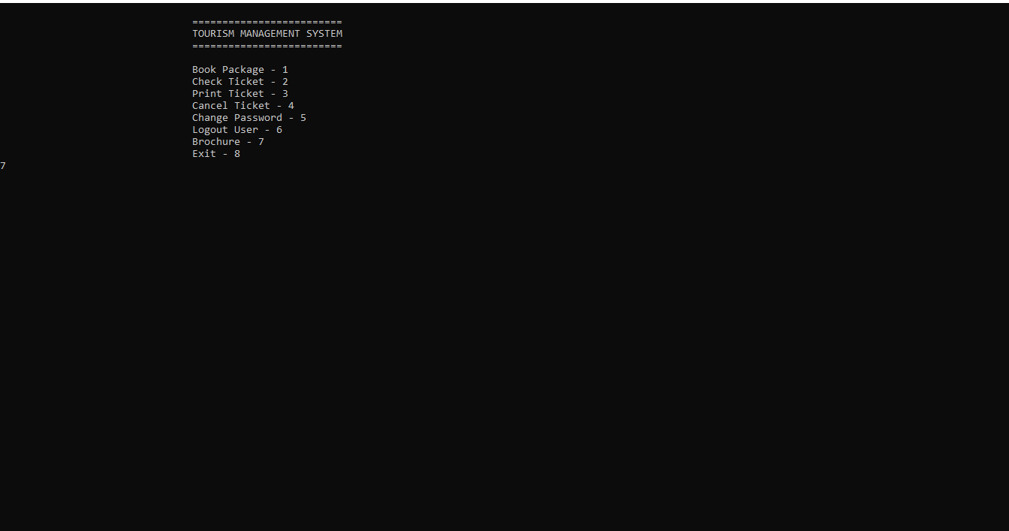

2.

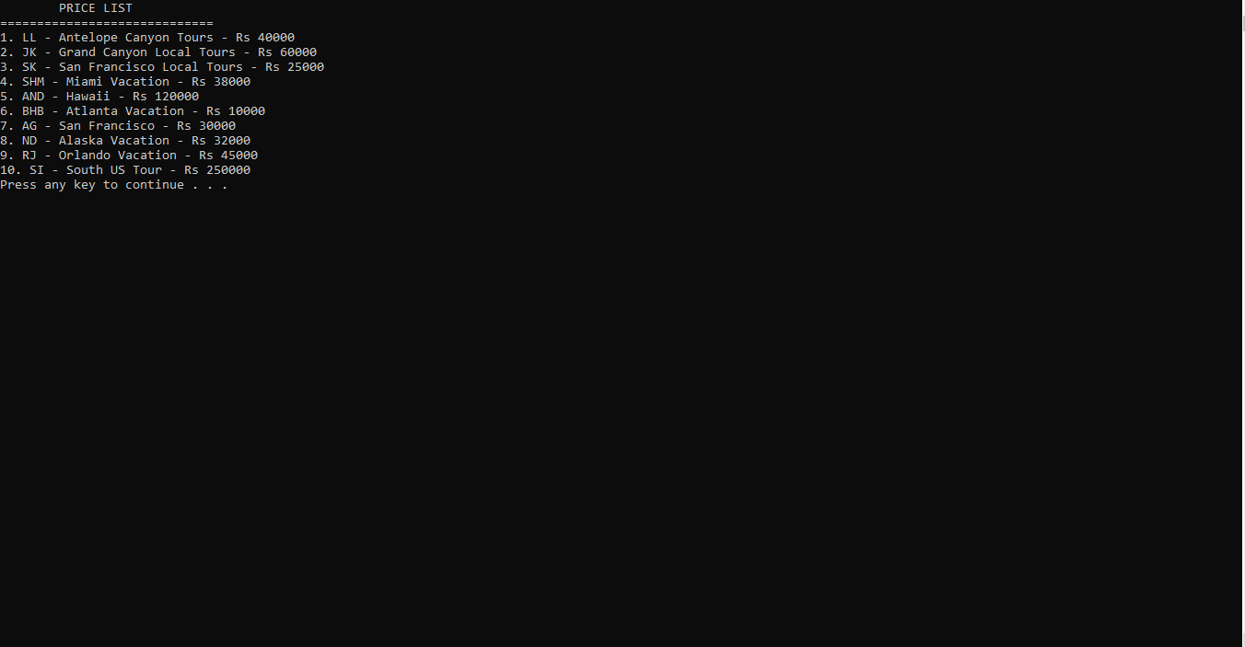

Change password

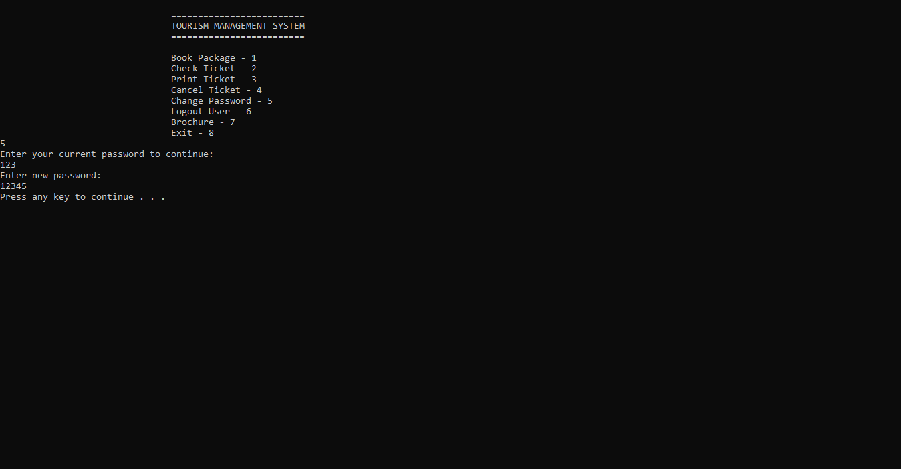

# 6.Conclusion:

The project entitled “TOURISIM MANANGEMENT **SYSTEM**” very convenient for the Customers to do online tour  packages easier. The main objective of the Tourisim manangement system is to manage the details of place , cost, number of passengers,cancelation,etc.. . This system is very convenient for passengers or users to book online tour packages. It can able to give you clear or proper information, and can be obtained easily and accurately.